Name:_______________________________________

Assignment 3: Graphing Puzzle Solution

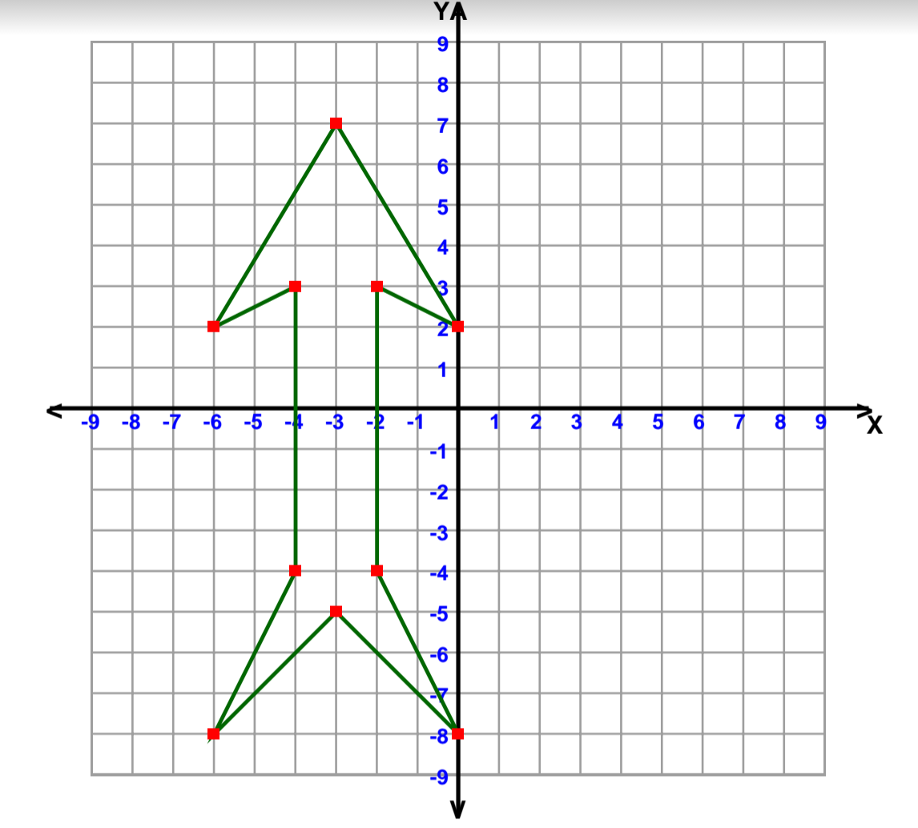

What is the shape? Arrow